C LANGUAGE LAB FILE

- ARRAY INSERTION , DELETION ,DISPLAY
#include <stdio.h>

int main() {
int arr[10] = {10, 20, 30, 40, 50};
int n = 5, i;

// DISPLAY
printf("Original array:\n");
for(i = 0; i < n; i++) {
printf("%d ", arr[i]);
}

// INSERT (at position 2 → index 1)
int pos = 1, value = 25;

for(i = n - 1; i >= pos; i--) {
arr[i + 1] = arr[i];
}
arr[pos] = value;
n++;

printf("\nAfter insertion:\n");
for(i = 0; i < n; i++) {
printf("%d ", arr[i]);
}

// DELETE (from position 3 → index 2)
pos = 2;

for(i = pos; i < n - 1; i++) {
arr[i] = arr[i + 1];
}
n--;

printf("\nAfter deletion:\n");
for(i = 0; i < n; i++) {
printf("%d ", arr[i]);
}

return 0;
}
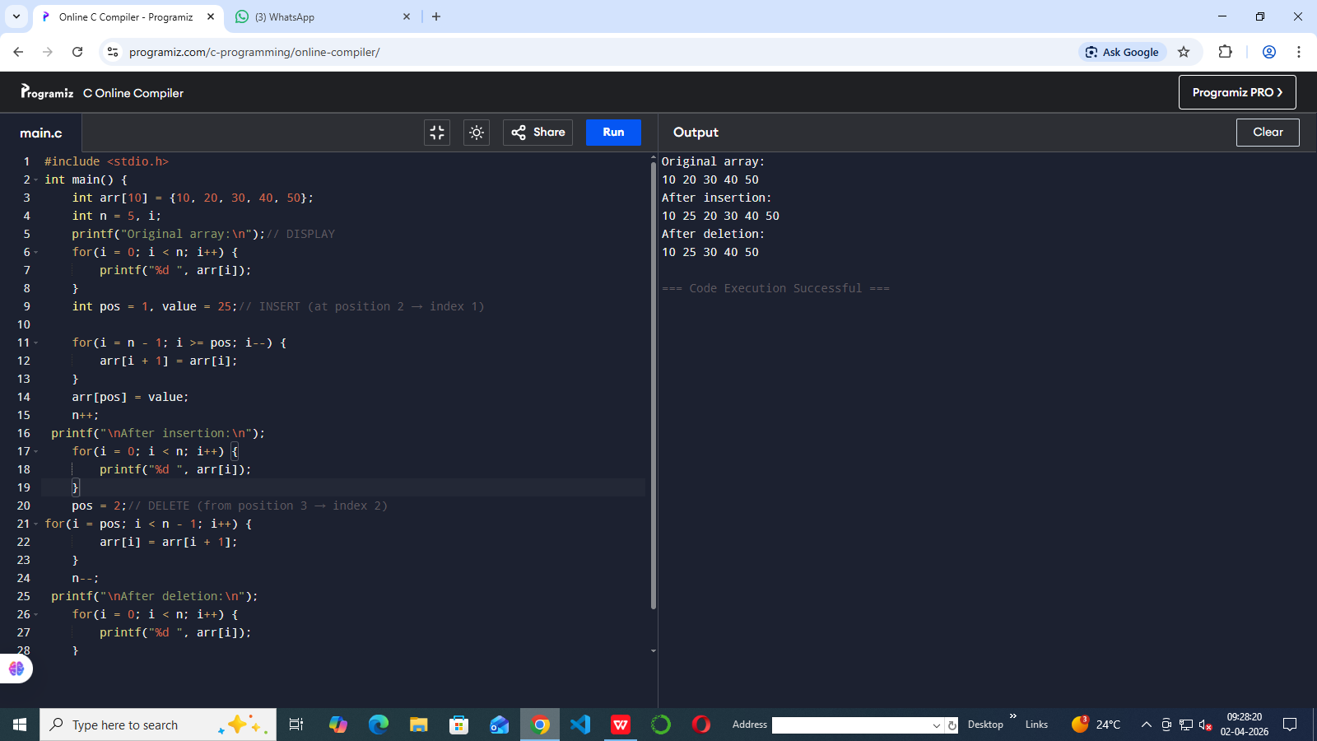

- ARITHMETIC OPERATIONS ON MATRICES
#include <stdio.h>
int main() {
int A[2][2] = {{1, 2}, {3, 4}};
int B[2][2] = {{5, 6}, {7, 8}};
int C[2][2];
int i, j, k;
printf("Addition:\n"); // Addition
for(i = 0; i < 2; i++) {
for(j = 0; j < 2; j++) {
C[i][j] = A[i][j] + B[i][j];
printf("%d ", C[i][j]);
}
printf("\n");
}
printf("\nSubtraction:\n"); // Subtraction
for(i = 0; i < 2; i++) {
for(j = 0; j < 2; j++) {
C[i][j] = A[i][j] - B[i][j];
printf("%d ", C[i][j]);
}
printf("\n");
}
printf("\nMultiplication:\n");// Multiplication
for(i = 0; i < 2; i++) {
for(j = 0; j < 2; j++) {
C[i][j] = 0;
for(k = 0; k < 2; k++) {
C[i][j] += A[i][k] * B[k][j];
}
printf("%d ", C[i][j]);
}
printf("\n");
}
return 0;
}
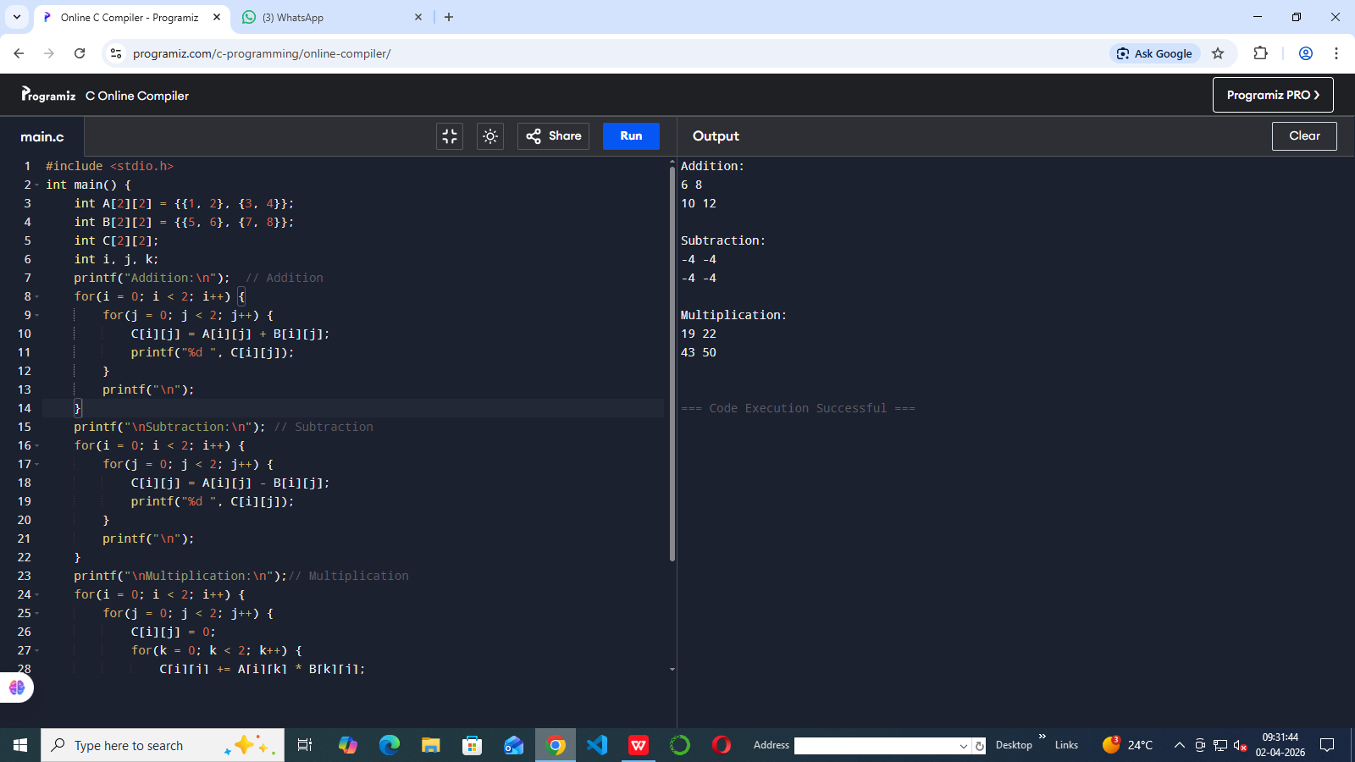
- BUBBLE SORT, QUICK SORT, INSERTION SORT,MERGE SORT, HEAP SORT
#include <stdio.h>
#include <stdlib.h>
void printArray(int arr[], int n) {
for(int i = 0; i < n; i++)
printf("%d ", arr[i]);
printf("\n");
}
void swap(int *a, int *b) {
int temp = *a;
*a = *b;
*b = temp;
}
void bubbleSort(int arr[], int n) {
for(int i = 0; i < n-1; i++) {
for(int j = 0; j < n-i-1; j++) {
if(arr[j] > arr[j+1])
swap(&arr[j], &arr[j+1]);
}
}
}
void insertionSort(int arr[], int n) {
for(int i = 1; i < n; i++) {
int key = arr[i];
int j = i - 1;
while(j >= 0 && arr[j] > key) {
arr[j + 1] = arr[j];
j--;
}
arr[j + 1] = key;
}
}
int partition(int arr[], int low, int high) {
int pivot = arr[high];
int i = low - 1;
for(int j = low; j < high; j++) {
if(arr[j] < pivot) {
i++;
swap(&arr[i], &arr[j]);
}
}
swap(&arr[i + 1], &arr[high]);
return i + 1;
}
void quickSort(int arr[], int low, int high) {
if(low < high) {
int pi = partition(arr, low, high);
quickSort(arr, low, pi - 1);
quickSort(arr, pi + 1, high);
}
}
void merge(int arr[], int l, int m, int r) {
int i, j, k;
int n1 = m - l + 1;
int n2 = r - m;
int L[n1], R[n2];
for(i = 0; i < n1; i++)
L[i] = arr[l + i];
for(j = 0; j < n2; j++)
R[j] = arr[m + 1 + j];
i = 0; j = 0; k = l;
while(i < n1 && j < n2) {
if(L[i] <= R[j])
arr[k++] = L[i++];
else
arr[k++] = R[j++];
}
while(i < n1)
arr[k++] = L[i++];
while(j < n2)
arr[k++] = R[j++];
}
void mergeSort(int arr[], int l, int r) {
if(l < r) {
int m = (l + r) / 2;
mergeSort(arr, l, m);
mergeSort(arr, m + 1, r);
merge(arr, l, m, r);
}
}
void heapify(int arr[], int n, int i) {
int largest = i;
int left = 2*i + 1;
int right = 2*i + 2;
if(left < n && arr[left] > arr[largest])
largest = left;
if(right < n && arr[right] > arr[largest])
largest = right;
if(largest != i) {
swap(&arr[i], &arr[largest]);
heapify(arr, n, largest);
}
}
void heapSort(int arr[], int n) {
for(int i = n/2 - 1; i >= 0; i--)
heapify(arr, n, i);
for(int i = n-1; i > 0; i--) {
swap(&arr[0], &arr[i]);
heapify(arr, i, 0);
}
}
int main() {
int arr[] = {64, 34, 25, 12, 22, 11, 90};
int n = sizeof(arr)/sizeof(arr[0]);
int temp[n];
printf("Original Array:\n");
printArray(arr, n);
for(int i=0;i<n;i++) temp[i]=arr[i];
bubbleSort(temp, n);
printf("\nBubble Sort:\n");
printArray(temp, n);
for(int i=0;i<n;i++) temp[i]=arr[i];
insertionSort(temp, n);
printf("\nInsertion Sort:\n");
printArray(temp, n);
for(int i=0;i<n;i++) temp[i]=arr[i];
quickSort(temp, 0, n-1);
printf("\nQuick Sort:\n");
printArray(temp, n);
for(int i=0;i<n;i++) temp[i]=arr[i];
mergeSort(temp, 0, n-1);
printf("\nMerge Sort:\n");
printArray(temp, n);
for(int i=0;i<n;i++) temp[i]=arr[i];
heapSort(temp, n);
printf("\nHeap Sort:\n");
printArray(temp, n);
return 0;
}
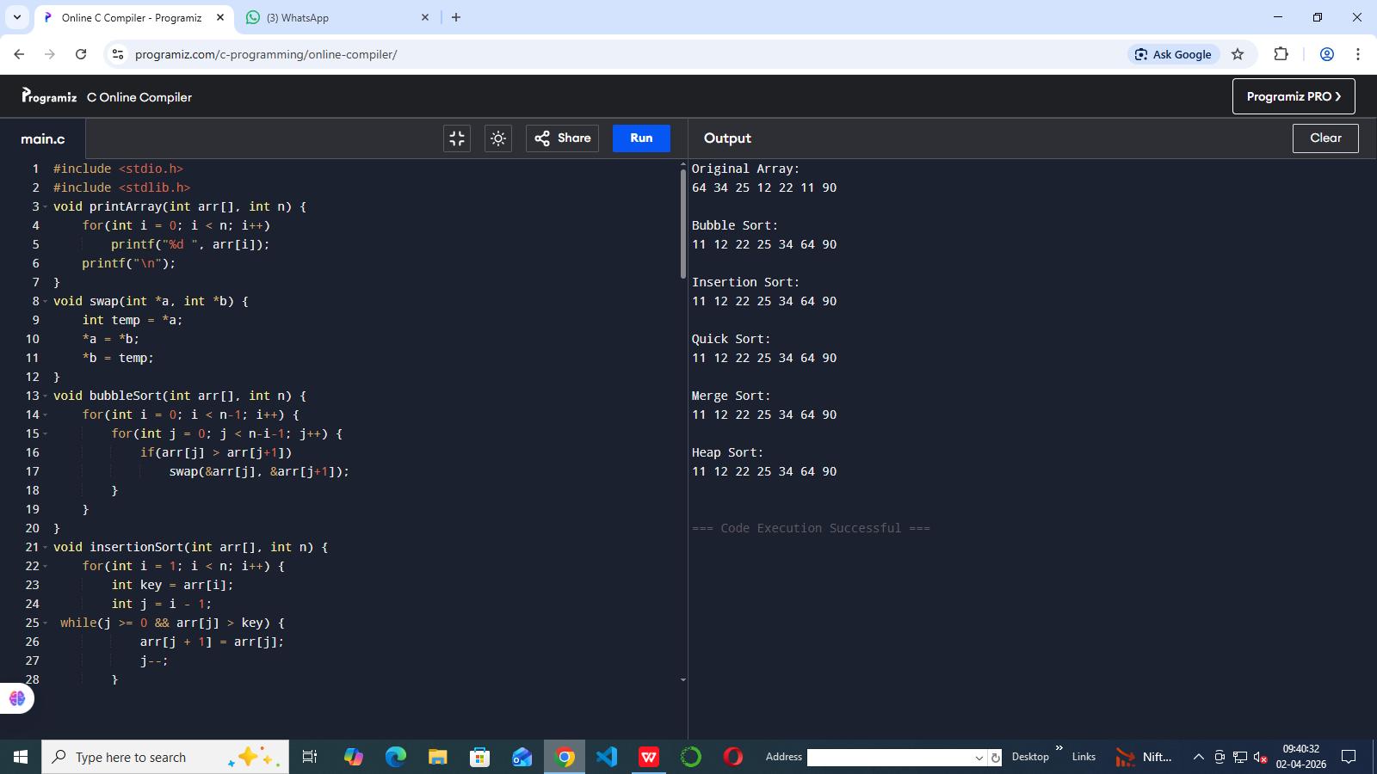

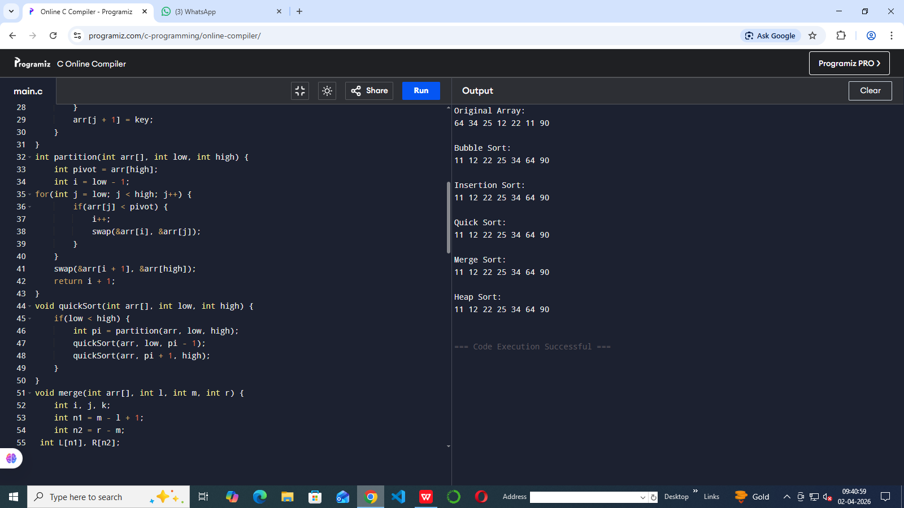

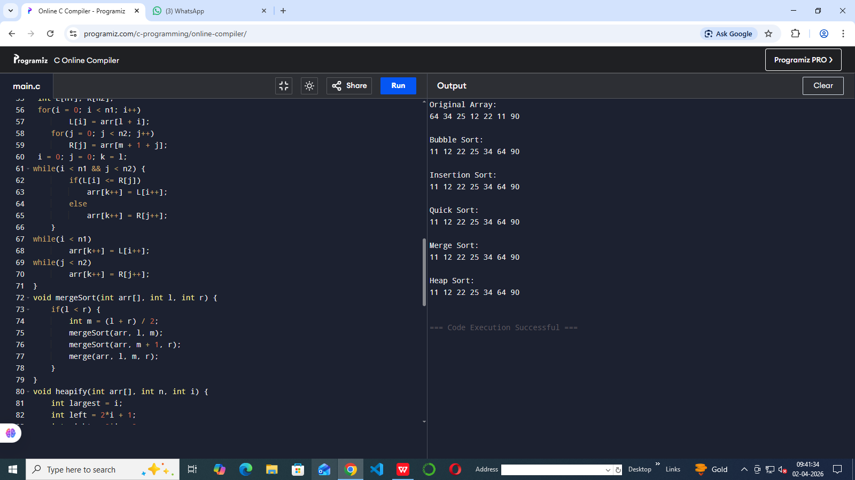

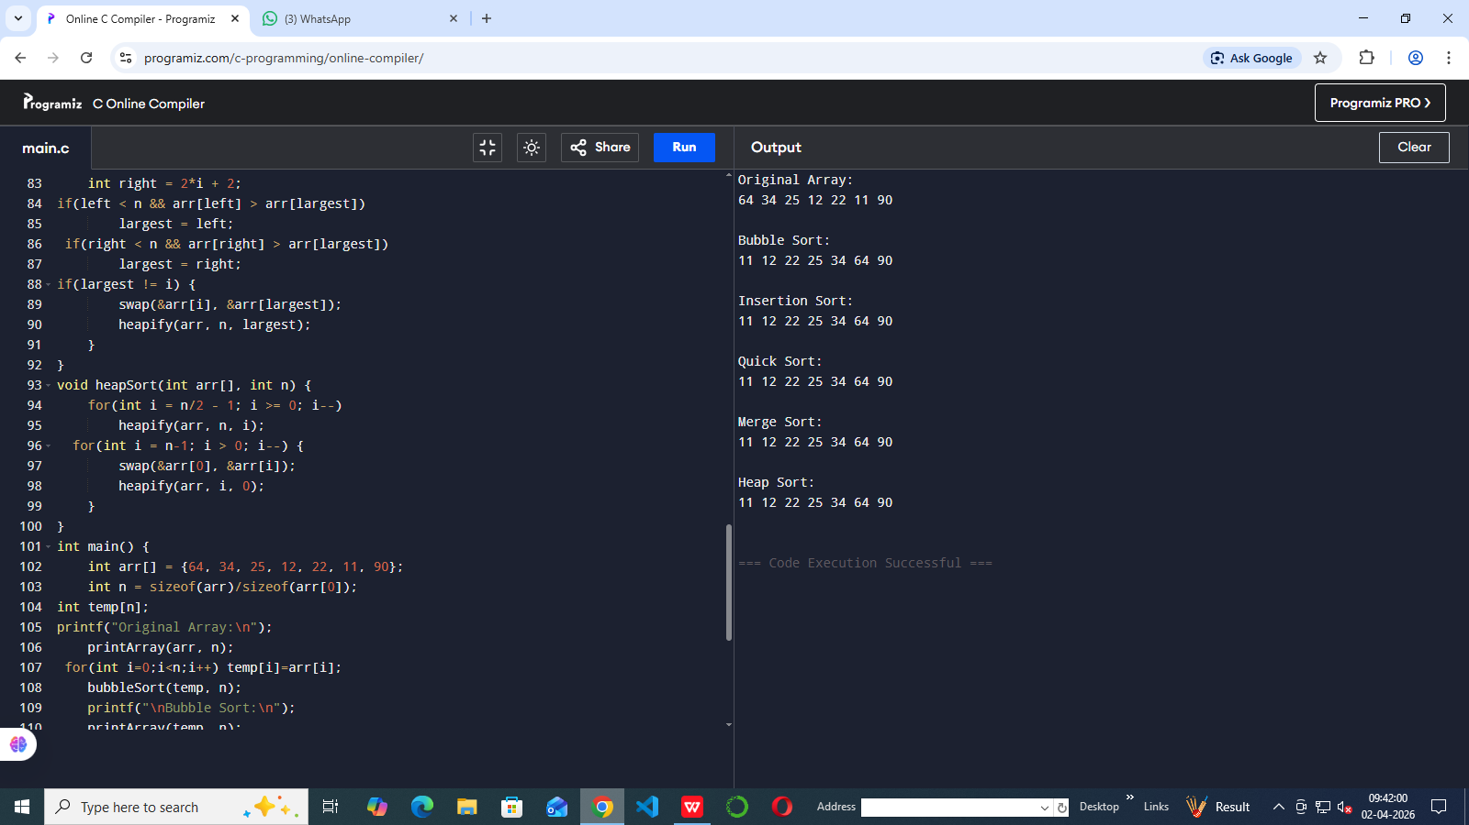
- LINEAR SEARCH , BINARY SEARCH
#include <stdio.h>
int main() {
int a[5] = {10, 20, 30, 40, 50}; // sorted
int key = 30;
int i;
// Linear Search
for(i = 0; i < 5; i++) {
if(a[i] == key) {
printf("Linear: Found at %d\n", i);
break;
}
}
int low = 0, high = 4, mid; // Binary Search

while(low <= high) {
mid = (low + high) / 2;
if(a[mid] == key) {
printf("Binary: Found at %d", mid);
break;
}
else if(a[mid] < key)
low = mid + 1;
else
high = mid - 1;
}
return 0;
}
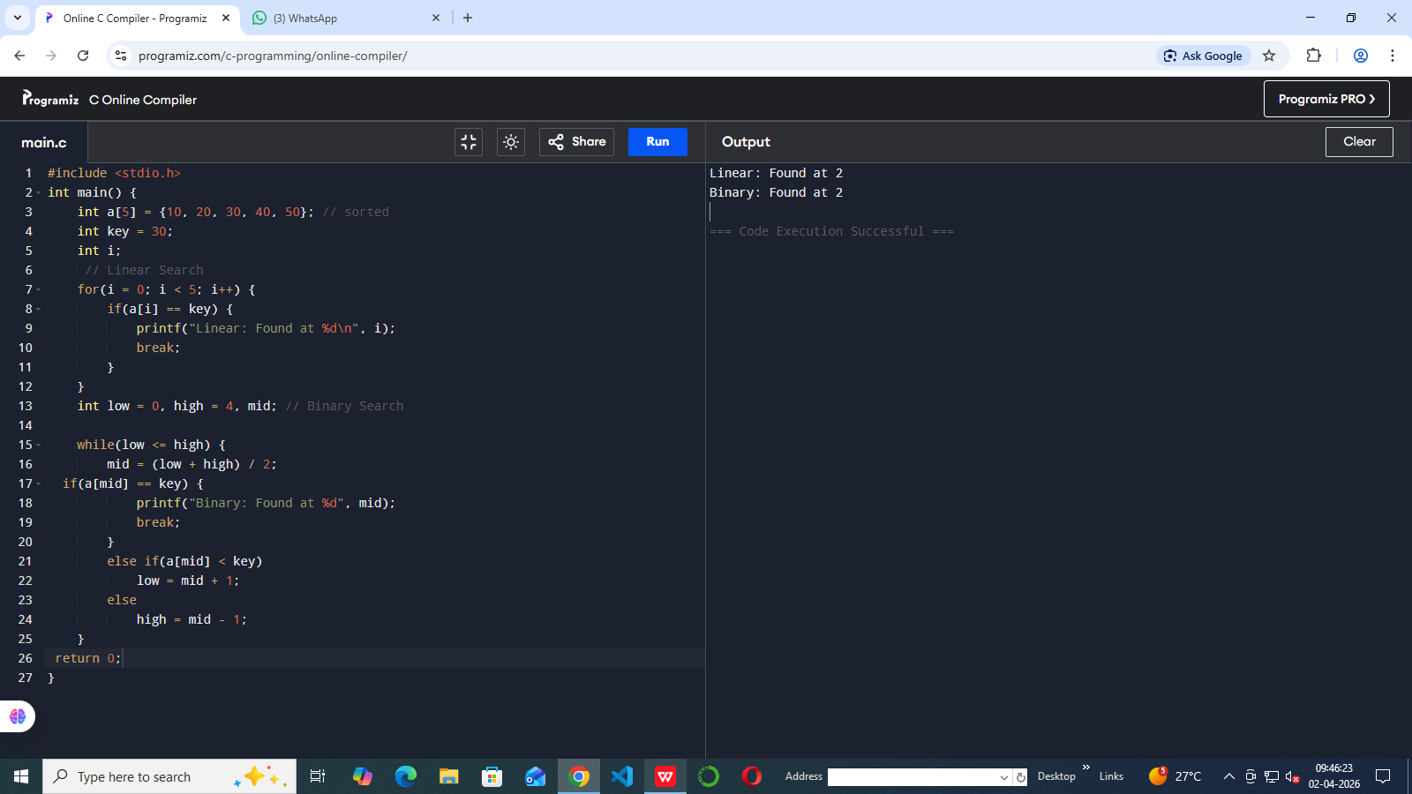
- STACK , QUEUE , CIRCULAR QUEUE
#include <stdio.h>
#define MAX 5
// STACK
int stack[MAX], top = -1;
// QUEUE
int queue[MAX], front = -1, rear = -1;
// CIRCULAR QUEUE
int cq[MAX], f = -1, r = -1;
int main() {
// -------- STACK --------
printf("STACK:\n");
stack[++top] = 10;
stack[++top] = 20;
stack[++top] = 30;
for(int i = top; i >= 0; i--)
printf("%d ", stack[i]);
printf("\nPop: %d\n", stack[top--]);
// -------- QUEUE --------
printf("\nQUEUE:\n");
if(front == -1) front = 0;
queue[++rear] = 10;
queue[++rear] = 20;
queue[++rear] = 30;
for(int i = front; i <= rear; i++)
printf("%d ", queue[i]);
printf("\nDelete: %d\n", queue[front++]);
// -------- CIRCULAR QUEUE --------
printf("\nCIRCULAR QUEUE:\n");
f = r = 0;
cq[r] = 10;
r = (r + 1) % MAX; cq[r] = 20;
r = (r + 1) % MAX; cq[r] = 30;
int i = f;
while(1) {
printf("%d ", cq[i]);
if(i == r) break;
i = (i + 1) % MAX;
}
printf("\nDelete: %d\n", cq[f]);
f = (f + 1) % MAX;
return 0;
}
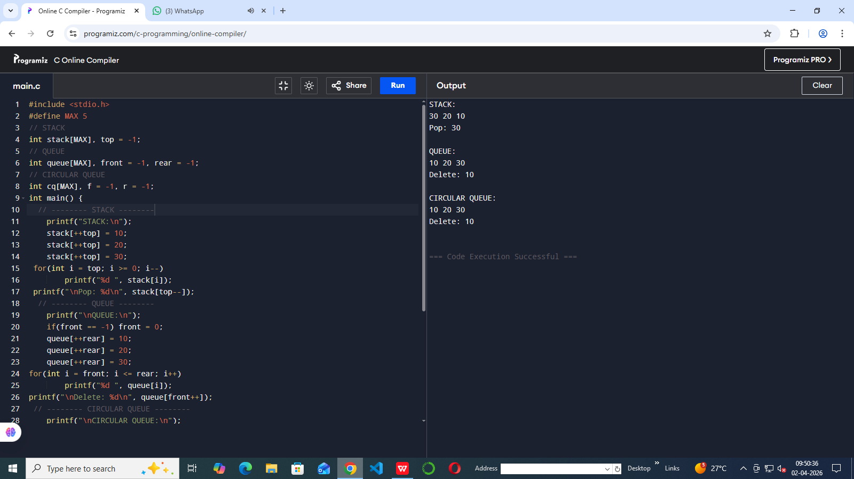
- Evaluate postfix expression
#include <stdio.h>
#include <ctype.h>
int stack[20], top = -1;
// push
void push(int x) {
stack[++top] = x;
}
// pop
int pop() {
return stack[top--];
}
int main() {
char exp[20];
int i, a, b;
printf("Enter postfix expression (e.g. 23+5*): ");
scanf("%s", exp);
for(i = 0; exp[i] != '\0'; i++) {
// if digit, push
if(isdigit(exp[i])) {
push(exp[i] - '0'); // convert char to int
}
else {
b = pop();
a = pop();
switch(exp[i]) {
case '+': push(a + b); break;
case '-': push(a - b); break;
case '*': push(a * b); break;
case '/': push(a / b); break;
}
}
}
printf("Result = %d", pop());
return 0;
}
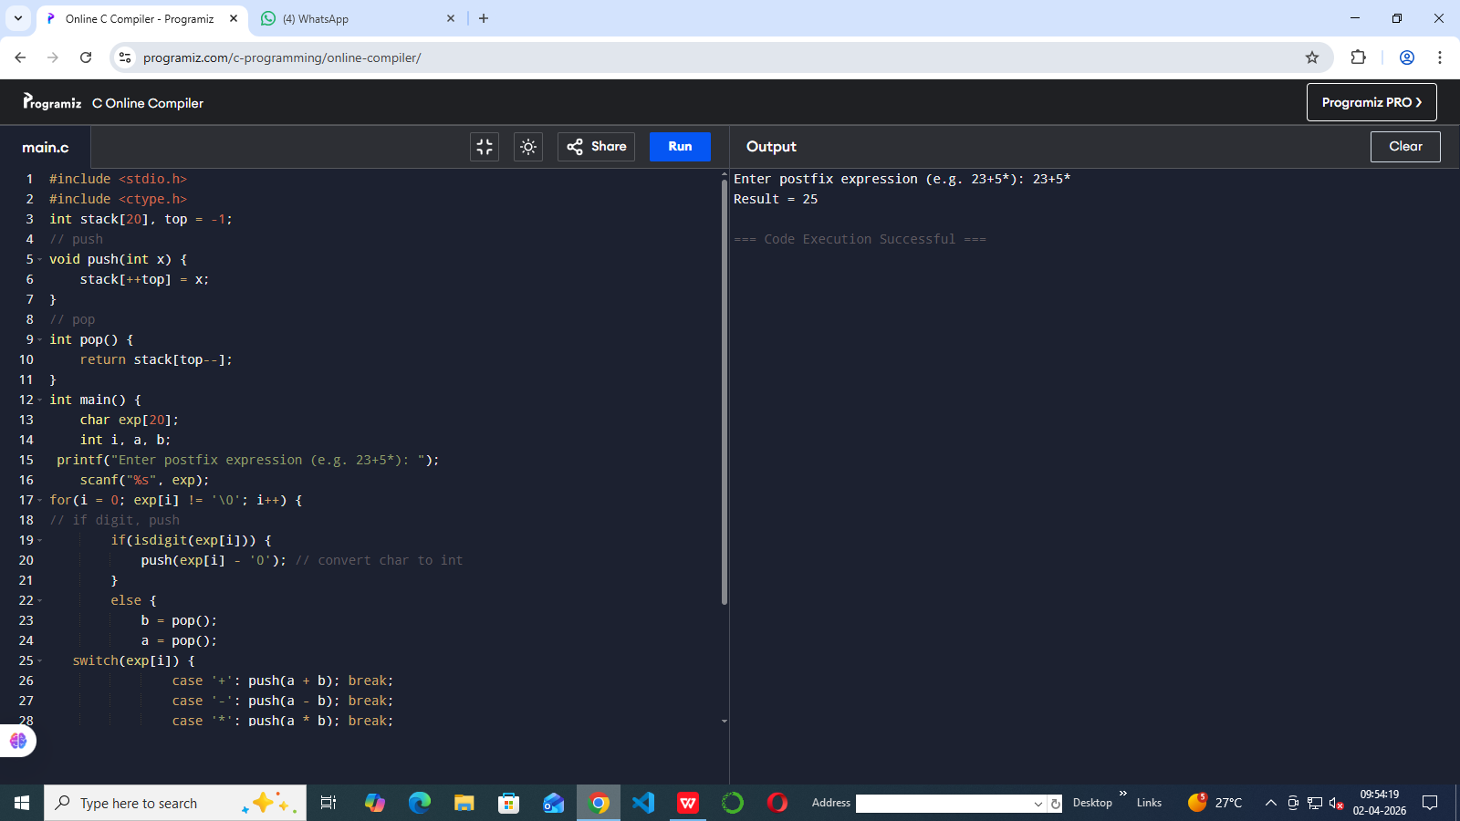
7.Infix to postfix
#include <stdio.h>
#include <ctype.h>
char stack[20];
int top = -1;
// push
void push(char x) {
stack[++top] = x;
}
// pop
char pop() {
return stack[top--];
}
int main() {
char infix[20], postfix[20];
int i, j = 0;
printf("Enter infix: ");
scanf("%s", infix);
for(i = 0; infix[i] != '\0'; i++) {
// operand
if(isalnum(infix[i])) {
postfix[j++] = infix[i];
}
// '('
else if(infix[i] == '(') {
push(infix[i]);
}
// ')'
else if(infix[i] == ')') {
while(stack[top] != '(')
postfix[j++] = pop();
pop();
}
// operator (+ - * /)
else {
while(top != -1 && stack[top] != '(')
postfix[j++] = pop();
push(infix[i]);
}
}
// remaining
while(top != -1)
postfix[j++] = pop();
postfix[j] = '\0';
printf("Postfix: %s", postfix);
return 0;
}
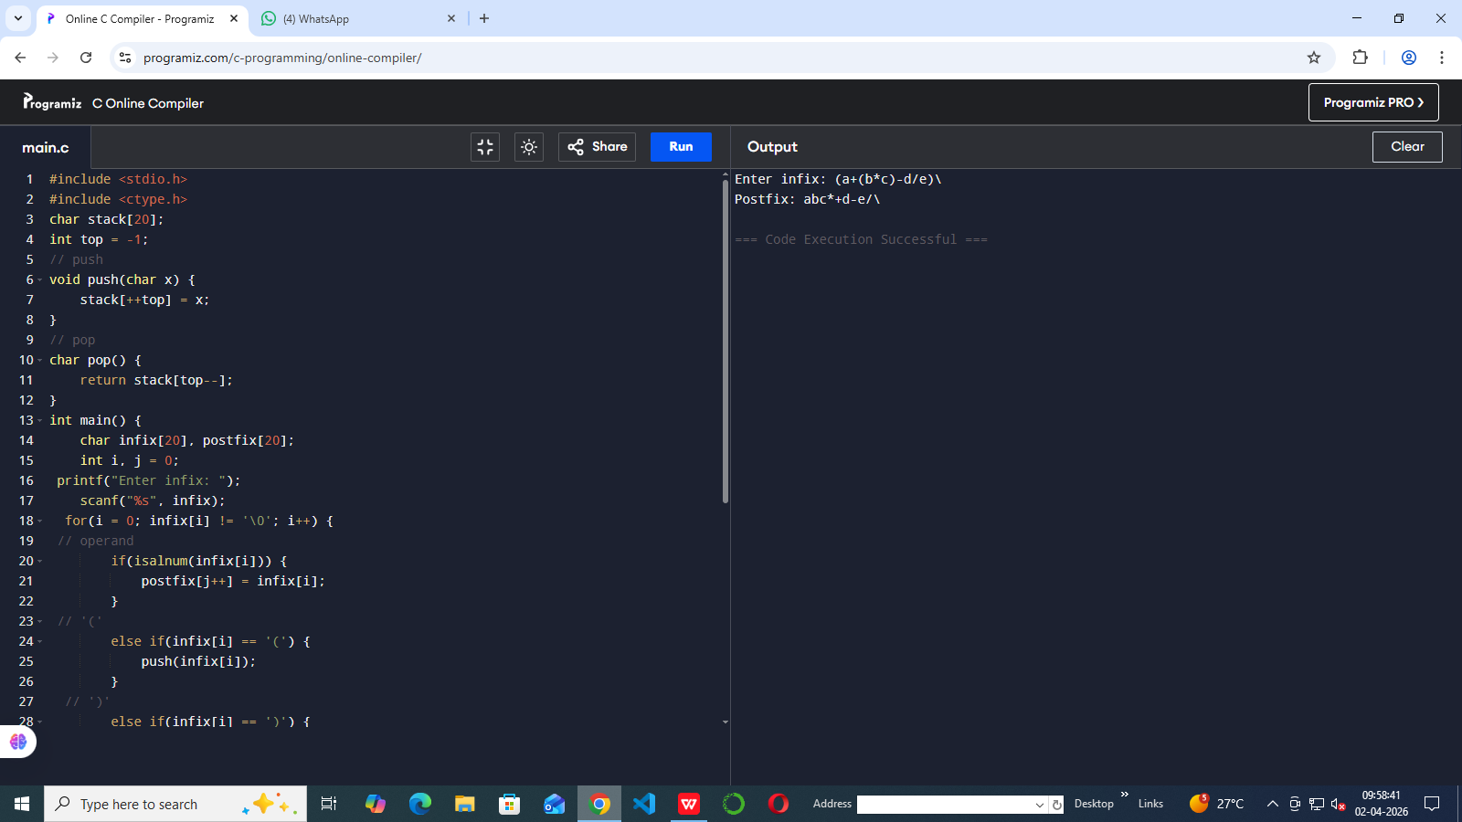
8.Insertion,deletion and display in linked list
#include <stdio.h>
#include <stdlib.h>
// Node structure
struct node {
int data;
struct node* next;
};
struct node* head = NULL;
// INSERT at beginning
void insert(int x) {
struct node* newnode = (struct node*)malloc(sizeof(struct node));
newnode->data = x;
newnode->next = head;
head = newnode;
}
// DELETE from beginning
void delete() {
if(head == NULL) {
printf("List is empty\n");
return;
}
struct node* temp = head;
printf("Deleted: %d\n", temp->data);
head = head->next;
free(temp);
}
// DISPLAY
void display() {
struct node* temp = head;
while(temp != NULL) {
printf("%d -> ", temp->data);
temp = temp->next;
}
printf("NULL\n");
}
int main() {
insert(10);
insert(20);
insert(30);
printf("List:\n");
display();
delete();
printf("After deletion:\n");
display();
return 0;
}
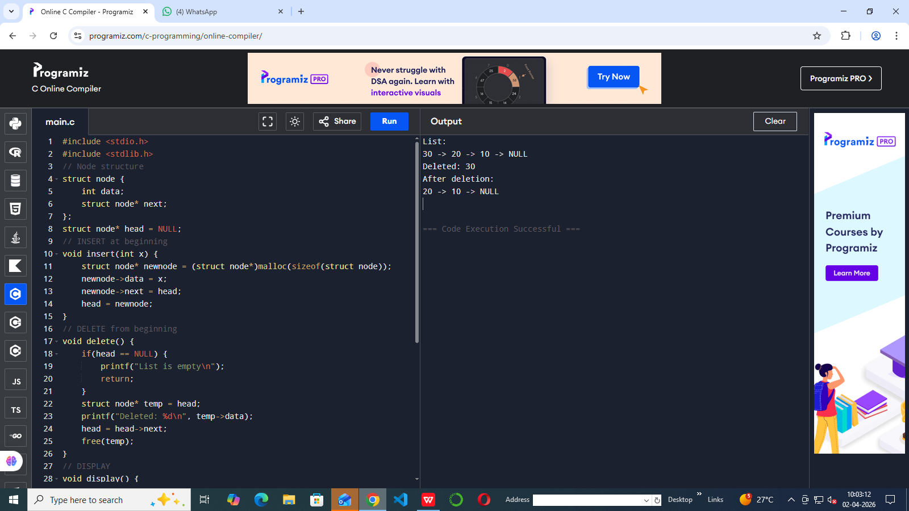
- Insertion,deletion and display in circular linked list
#include <stdio.h>
#include <stdlib.h>
struct node {
int data;
struct node* next;
};
struct node* last = NULL;
// INSERT at end
void insert(int x) {
struct node* newnode = (struct node*)malloc(sizeof(struct node));
newnode->data = x;
if(last == NULL) {
last = newnode;
last->next = last;
} else {
newnode->next = last->next;
last->next = newnode;
last = newnode;
}
}
// DELETE from beginning
void delete() {
if(last == NULL) {
printf("List empty\n");
return;
}
struct node* temp = last->next;
if(last->next == last) {
last = NULL;
} else {
last->next = temp->next;
}
printf("Deleted: %d\n", temp->data);
free(temp);
}
// DISPLAY
void display() {
if(last == NULL) {
printf("List empty\n");
return;
}
struct node* temp = last->next;
do {
printf("%d -> ", temp->data);
temp = temp->next;
} while(temp != last->next);

printf("(back to start)\n");
}
int main() {
insert(10);
insert(20);
insert(30);
printf("List:\n");
display();
delete();
printf("After deletion:\n");
display();
return 0;
}
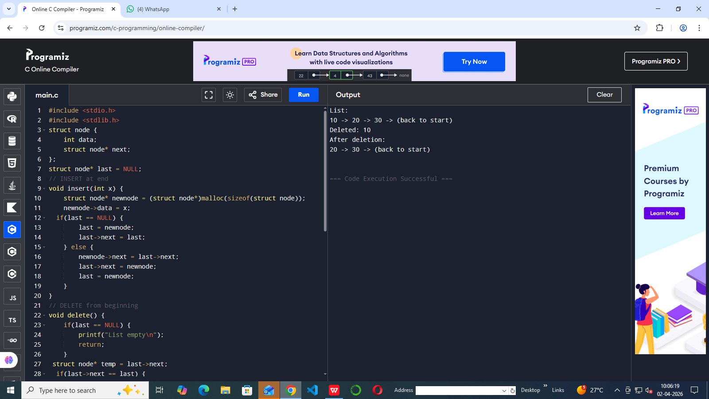
10.program to perform all operations.
i)stack using linked list
#include <stdio.h>
#include <stdlib.h>
struct node {
int data;
struct node* next;
};
struct node* top = NULL;
// PUSH
void push(int x) {
struct node* newnode = (struct node*)malloc(sizeof(struct node));
newnode->data = x;
newnode->next = top;
top = newnode;
}
// POP
void pop() {
if (top == NULL) {
printf("Stack Underflow\n");
} else {
struct node* temp = top;
printf("Deleted: %d\n", temp->data);
top = top->next;
free(temp);
}
}
// DISPLAY
void display() {
struct node* temp = top;
while (temp != NULL) {
printf("%d -> ", temp->data);
temp = temp->next;
}
printf("NULL\n");
}
int main() {
push(10);
push(20);
push(30);
display();
pop();
display();
}
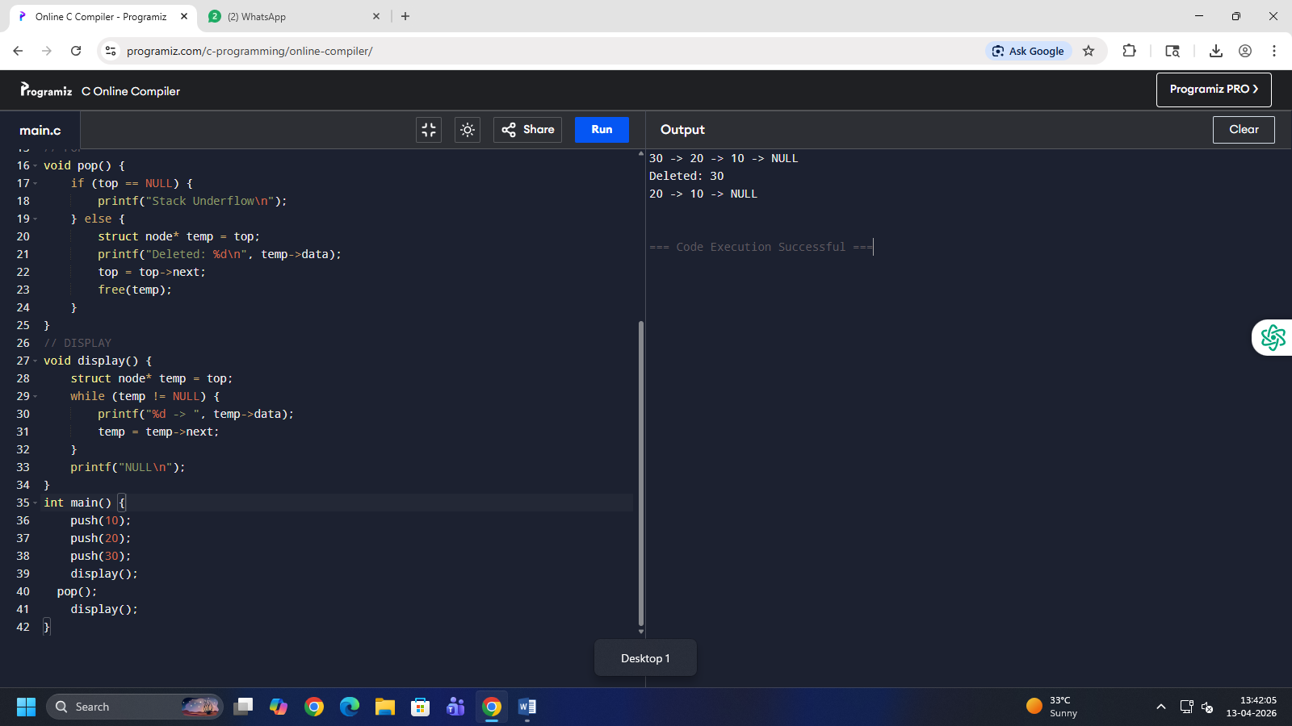
ii)queue using linked list.
#include <stdio.h>
#include <stdlib.h>
struct node {
int data;
struct node* next;
};
struct node *front = NULL, *rear = NULL;
// ENQUEUE
void enqueue(int x) {
struct node* newnode = (struct node*)malloc(sizeof(struct node));
newnode->data = x;
newnode->next = NULL;
if (rear == NULL) {
front = rear = newnode;
} else {
rear->next = newnode;
rear = newnode;
}
}
// DEQUEUE
void dequeue() {
if (front == NULL) {
printf("Queue Underflow\n");
} else {
struct node* temp = front;
printf("Deleted: %d\n", temp->data);
front = front->next;
free(temp);
if (front == NULL)
rear = NULL;
}
}
// DISPLAY
void display() {
struct node* temp = front;
while (temp != NULL) {
printf("%d -> ", temp->data);
temp = temp->next;
}
printf("NULL\n");
}
int main() {
enqueue(10);
enqueue(20);
enqueue(30);
display();
dequeue();
display();
}
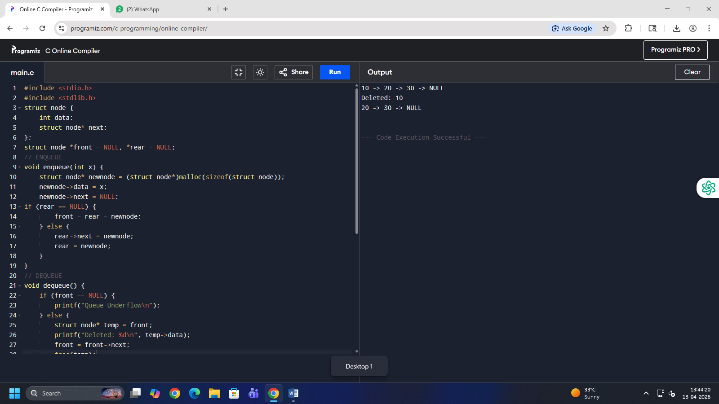
iii)circular queue using linked list
#include <stdio.h>
#include <stdlib.h>
struct node {
int data;
struct node* next;
};
struct node *front = NULL, *rear = NULL;
// ENQUEUE
void enqueue(int x) {
struct node* newnode = (struct node*)malloc(sizeof(struct node));
newnode->data = x;
if (rear == NULL) {
front = rear = newnode;
rear->next = front;
} else {
rear->next = newnode;
rear = newnode;
rear->next = front;
}
}
// DEQUEUE
void dequeue() {
if (front == NULL) {
printf("Queue Underflow\n");
} else if (front == rear) {
printf("Deleted: %d\n", front->data);
free(front);
front = rear = NULL;
} else {
struct node* temp = front;
printf("Deleted: %d\n", temp->data);
front = front->next;
rear->next = front;
free(temp);
}
}
// DISPLAY
void display() {
if (front == NULL) {
printf("Queue is empty\n");
return;
}
struct node* temp = front;
do {
printf("%d -> ", temp->data);
temp = temp->next;
} while (temp != front);
printf("(back to front)\n");
}
int main() {
enqueue(10);
enqueue(20);
enqueue(30);
display();
dequeue();
display();
}
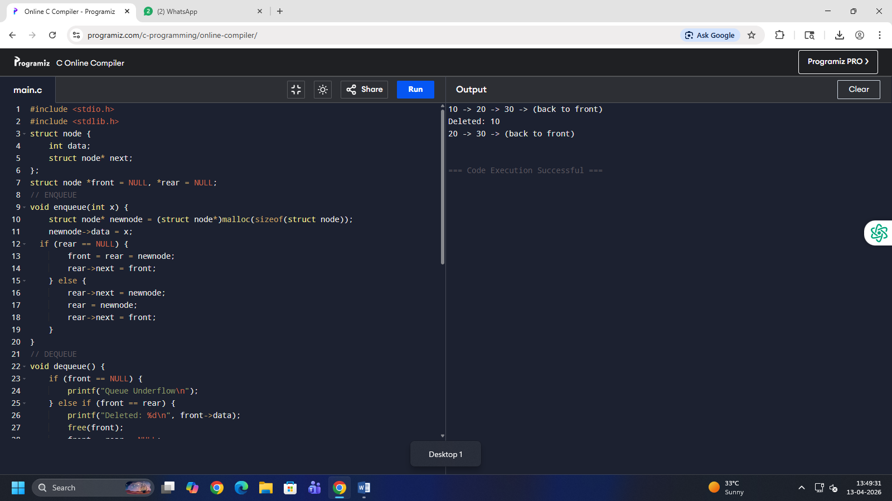
11)program to perform concatenation of 2 linked list
#include <stdio.h>
#include <stdlib.h>
struct node {
int data;
struct node* next;
};
// display
void display(struct node* h) {
while (h != NULL) {
printf("%d ", h->data);
h = h->next;
}
printf("\n");
}
int main() {
// list1: 1 -> 2 -> 3
struct node *h1, *h2, *t;
h1 = malloc(sizeof(struct node));
h1->data = 1;
h1->next = malloc(sizeof(struct node));
h1->next->data = 2;
h1->next->next = malloc(sizeof(struct node));
h1->next->next->data = 3;
h1->next->next->next = NULL;
// list2: 4 -> 5
h2 = malloc(sizeof(struct node));
h2->data = 4;
h2->next = malloc(sizeof(struct node));
h2->next->data = 5;
h2->next->next = NULL;
// concatenate
t = h1;
while (t->next != NULL)
t = t->next;
t->next = h2;
// result
display(h1);
}
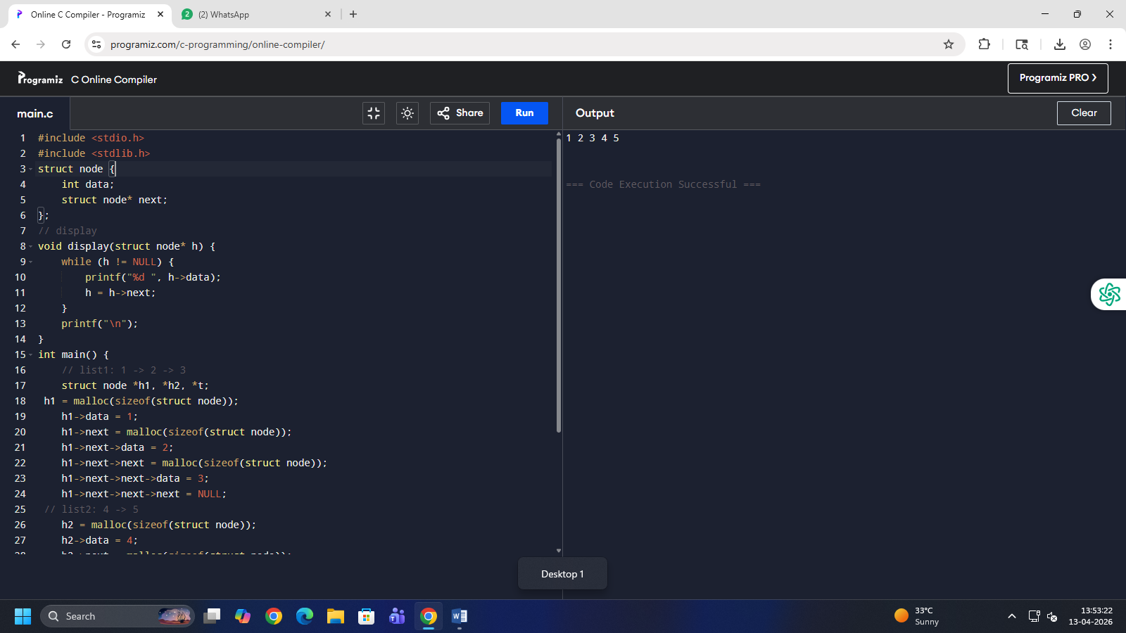
12.program to perform operations on doubly linked list.
#include <stdio.h>
#include <stdlib.h>
struct node {
int data;
struct node* prev;
struct node* next;
};
struct node* head = NULL;
// INSERT at beginning
void insert(int x) {
struct node* n = malloc(sizeof(struct node));
n->data = x;
n->prev = NULL;
n->next = head;
if (head != NULL)
head->prev = n;
head = n;
}
// DELETE from beginning
void del() {
if (head == NULL) {
printf("Empty\n");
return;
}
printf("Deleted %d\n", head->data);
head = head->next;

if (head != NULL)
head->prev = NULL;
}
// DISPLAY
void display() {
struct node* t = head;
while (t != NULL) {
printf("%d ", t->data);
t = t->next;
}
printf("\n");
}
int main() {
insert(1); insert(2); insert(3);
display();
del();
display();
}
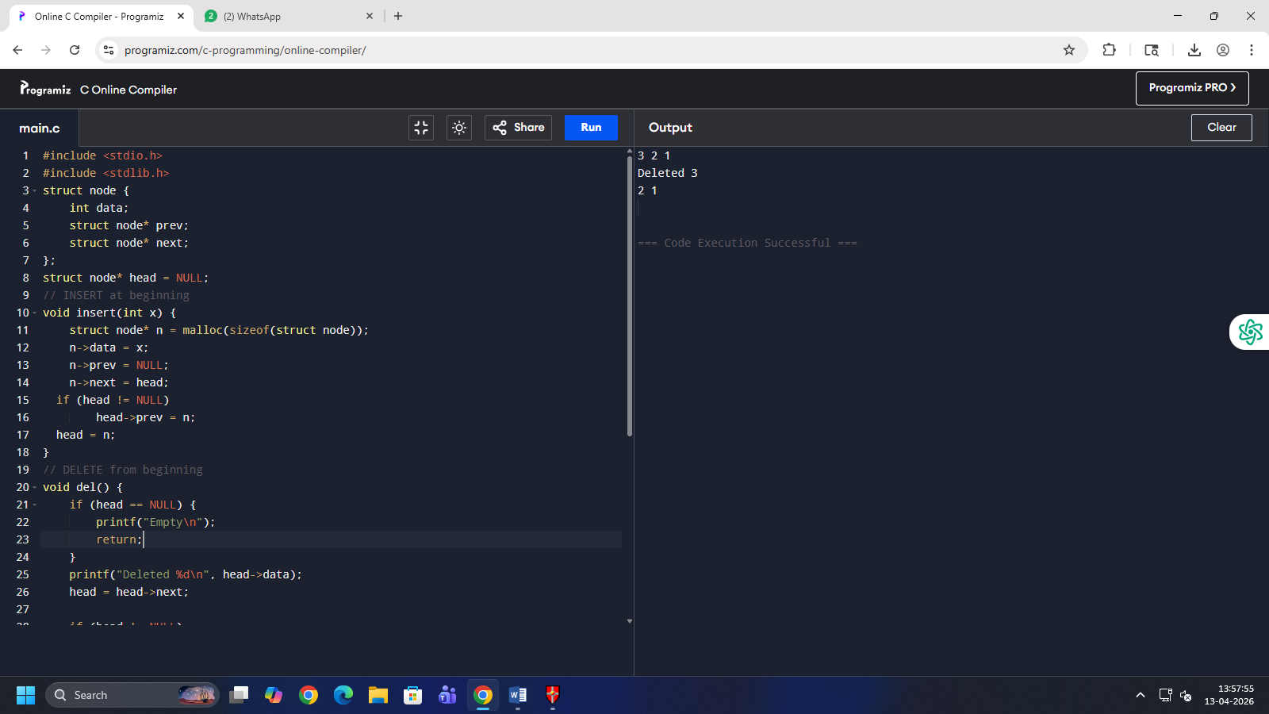
13.program to perform tree traversal methods.
#include <stdio.h>
#include <stdlib.h>
struct node {
int data;
struct node *left, *right;
};
// create node
struct node* newNode(int x) {
struct node* n = malloc(sizeof(struct node));
n->data = x;
n->left = n->right = NULL;
return n;
}
// INORDER (LNR)
void inorder(struct node* root) {
if (root != NULL) {
inorder(root->left);
printf("%d ", root->data);
inorder(root->right);
}
}
// PREORDER (NLR)
void preorder(struct node* root) {
if (root != NULL) {
printf("%d ", root->data);
preorder(root->left);
preorder(root->right);
}
}
// POSTORDER (LRN)
void postorder(struct node* root) {
if (root != NULL) {
postorder(root->left);
postorder(root->right);
printf("%d ", root->data);
}
}
int main() {
// simple tree
struct node* root = newNode(1);
root->left = newNode(2);
root->right = newNode(3);
printf("Inorder: ");
inorder(root);
printf("\nPreorder: ");
preorder(root);
printf("\nPostorder: ");
postorder(root);
}
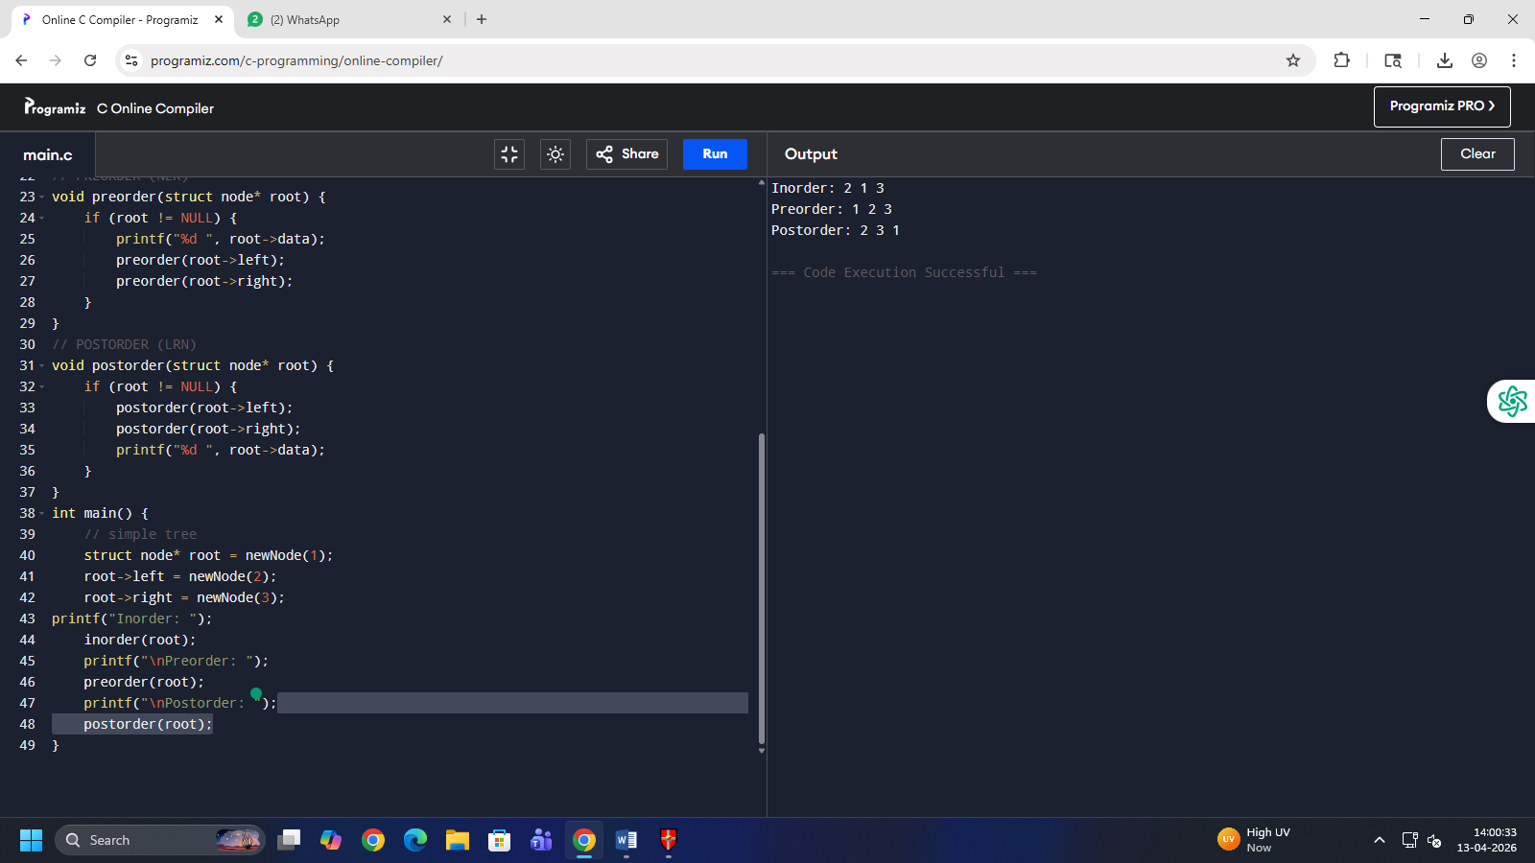
14.operations on binary search tree
#include <stdio.h>
#include <stdlib.h>
struct node {
int data;
struct node *left, *right;
};
// create node
struct node* newNode(int x) {
struct node* n = malloc(sizeof(struct node));
n->data = x;
n->left = n->right = NULL;
return n;
}
// insert
struct node* insert(struct node* r, int x) {
if (r == NULL) return newNode(x);
if (x < r->data)
r->left = insert(r->left, x);
else
r->right = insert(r->right, x);
return r;
}
// delete
struct node* del(struct node* r, int x) {
if (r == NULL) return r;
if (x < r->data)
r->left = del(r->left, x);
else if (x > r->data)
r->right = del(r->right, x);
else {
if (r->left == NULL) return r->right;
if (r->right == NULL) return r->left;
struct node* t = r->right;
while (t->left != NULL)
t = t->left;
r->data = t->data;
r->right = del(r->right, t->data);
}
return r;
}
// display (inorder)
void show(struct node* r) {
if (r != NULL) {
show(r->left);
printf("%d ", r->data);
show(r->right);
}
}
int main() {
struct node* root = NULL;
root = insert(root, 5);
insert(root, 3);
insert(root, 7);
insert(root, 2);
insert(root, 4);
printf("Before: ");
show(root);
root = del(root, 3);
printf("\nAfter: ");
show(root);
}
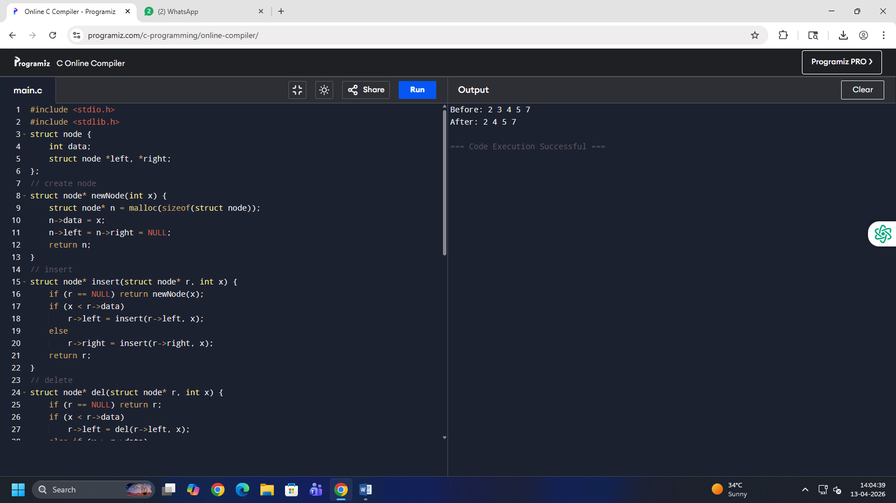
15.adjacency matrix(1.create graph 2.insert an edge 3. Print 4.list all vertices 5.exit)
#include <stdio.h>
int a[10][10], n;
// create
void create() {
int i, j;
printf("Vertices: ");
scanf("%d", &n);
for(i=0;i<n;i++)
for(j=0;j<n;j++)
a[i][j]=0;
}
// insert edge
void insert() {
int u,v;
printf("Enter edge: ");
scanf("%d%d",&u,&v);
a[u][v]=1;
a[v][u]=1;
}
// print
void print() {
int i,j;
for(i=0;i<n;i++) {
for(j=0;j<n;j++)
printf("%d ",a[i][j]);
printf("\n");
}
}
// adjacent vertices
void adjacent() {
int v,i;
printf("Vertex: ");
scanf("%d",&v);
for(i=0;i<n;i++)
if(a[v][i]==1)
printf("%d ",i);
printf("\n");
}
int main() {
int ch;
while(1) {
printf("\n1.Create 2.Insert 3.Print 4.Adjacent 5.Exit\n");
scanf("%d",&ch);
if(ch==1) create();
else if(ch==2) insert();
else if(ch==3) print();
else if(ch==4) adjacent();
else break;
}
}
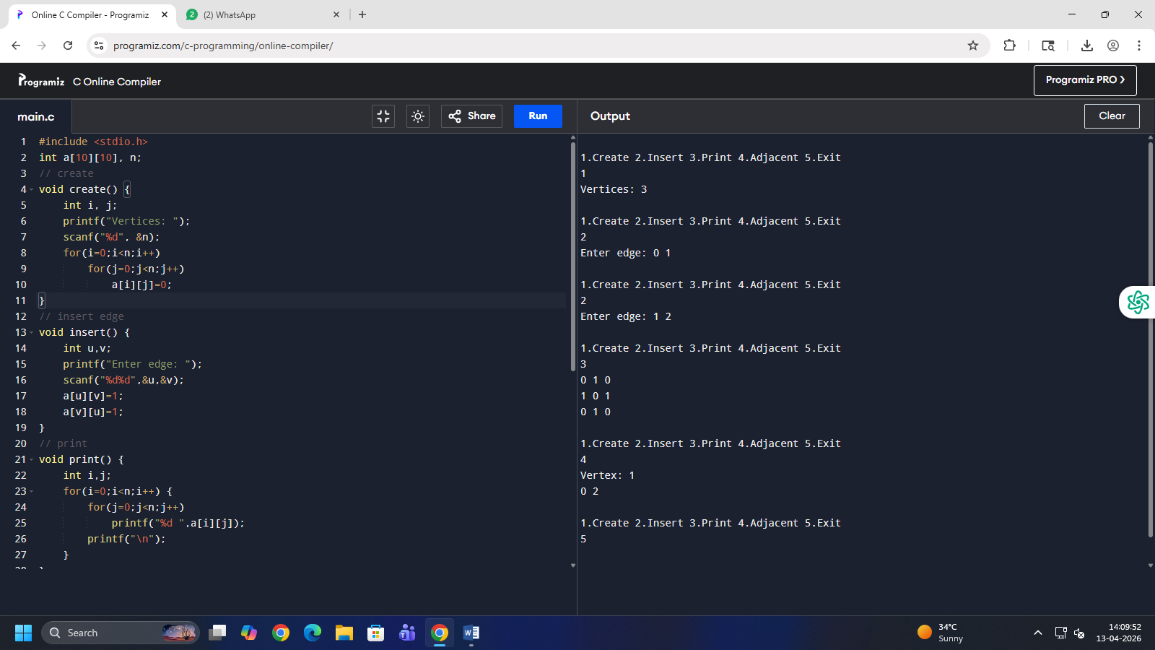
16.kalinirnay : conversion from Gregorian to hindi calender.
17.irrigation recommendation system.
#include <stdio.h>
#include <stdlib.h>
#include <string.h>
struct node {
char crop[20];
char soil[20];
char time[20];
struct node* next;
};
struct node* head = NULL;
// add data
void add(char c[], char s[], char t[]) {
struct node* n = malloc(sizeof(struct node));
strcpy(n->crop, c);
strcpy(n->soil, s);
strcpy(n->time, t);
n->next = head;
head = n;
}
// search recommendation
void recommend(char c[], char s[]) {
struct node* temp = head;
while(temp != NULL) {
if(strcmp(temp->crop,c)==0 && strcmp(temp->soil,s)==0) {
printf("Irrigation Time: %s\n", temp->time);
return;
}
temp = temp->next;
}
printf("No data found\n");
}
int main() {
add("Wheat","Loamy","5 days");
add("Rice","Clay","2 days");
add("Maize","Sandy","3 days");
recommend("Rice","Clay");
}
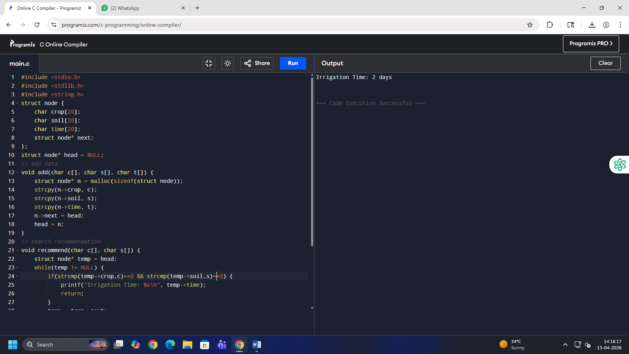
18.queue based appointment management system.
#include <stdio.h>
#include <stdlib.h>
#include <string.h>
struct node {
char name[20];
struct node* next;
};
struct node *front = NULL, *rear = NULL;
// Add patient
void addPatient(char name[]) {
struct node* n = malloc(sizeof(struct node));
strcpy(n->name, name);
n->next = NULL;
if (rear == NULL)
front = rear = n;
else {
rear->next = n;
rear = n;
}
}
// View next patient
void nextPatient() {
if (front == NULL)
printf("No patients\n");
else
printf("Next Patient: %s\n", front->name);
}
// Serve patient
void servePatient() {
if (front == NULL)
printf("No patients\n");
else {
printf("Serving: %s\n", front->name);
front = front->next;
if (front == NULL)
rear = NULL;
}
}
// Display all patients
void display() {
struct node* t = front;
if (t == NULL) {
printf("No patients\n");
return;
}
printf("Waiting Patients:\n");
while (t != NULL) {
printf("%s -> ", t->name);
t = t->next;
}
printf("NULL\n");
}
int main() {
int ch;
char name[20];
while (1) {
printf("\n1.Add 2.Next 3.Serve 4.Display 5.Exit\n");
scanf("%d", &ch);
if (ch == 1) {
printf("Enter name: ");
scanf("%s", name);
addPatient(name);
}
else if (ch == 2) nextPatient();
else if (ch == 3) servePatient();
else if (ch == 4) display();
else break;
}
}
